1. For the L Shaped Desks and Desk with Side Cabinet, the sketch should be like these instead

L shaped, user can choose either A or B (A is return on left, B is return on right)

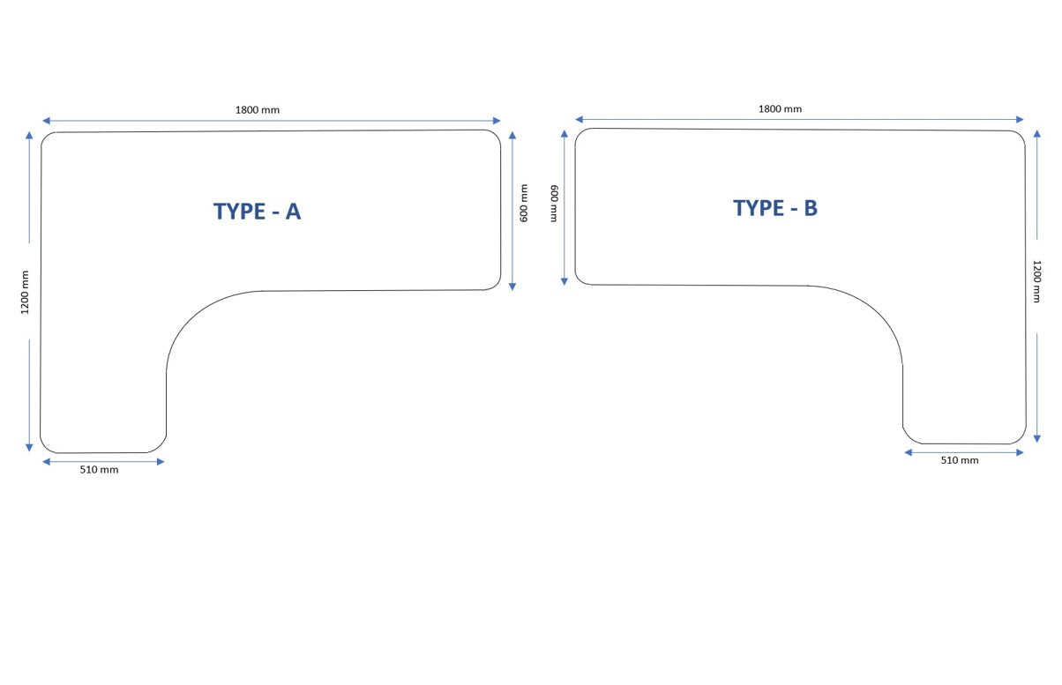

Desk with Side cabinet like below…

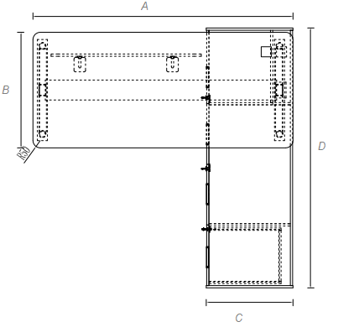

1. Can we try a plant like this instead? ( I asked before)

<https://www.freepik.com/premium-psd/wall-mockup-poster-frame-mockup-modern-study-room-interior_14451799.htm>

1. Can we have an info icon here next to word size

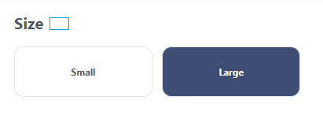

Then when clicked, I want to show this pop up words:

* Min Length for Single Leg Standing Desk is 500mm and Max Length is 1000mm.
* Min Length for 2 legsStanding Desk is 750mm and Max Length is 2000mm.
* Min Length for 3 legs Standing Desk is 1200mm and Max Length is 2000mm. Return Length must be at least 1200mm.
* Min Length for 4 legs Standing Desk is 1100mm and Max Length is 2400mm.

1. And here I want to add these text and an info icon

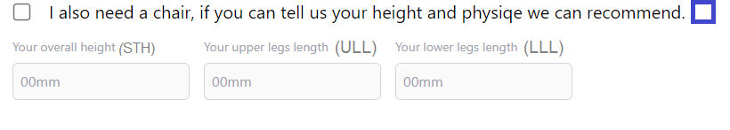

When Clicked, it should show the diagram below

